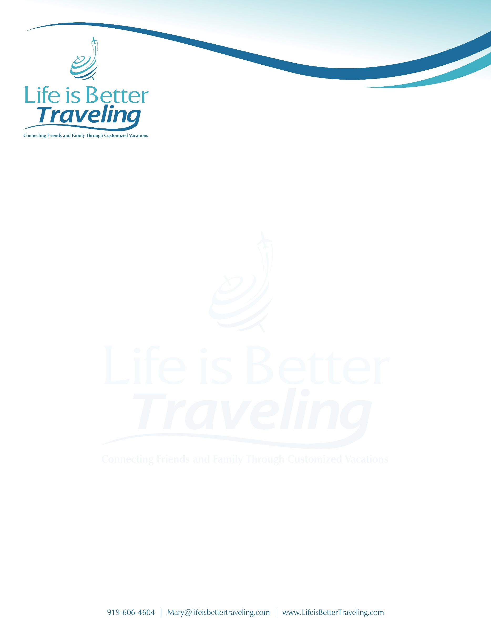

ADDRESS OF PLACE DATE

Dear NAME OF PERSON,
If you haven’t yet received the letter I sent to you, I have recently moved from NAME OF PREVIOUS Travel Agency to Life is Better Traveling, LLC. I would love to have you join me there!
Life is Better Traveling, LLC is a full-service travel agency that has outstanding relationships with many travel suppliers. This relationship allows us to often get amenities, upgrades, and other special VIP touches that my clients may not have access to otherwise.
Our agency is committed to making the best experience possible for their clients and one of the many perks that our clients love is the ONE PHONE guarantee. If our clients experience unexpected surprises during their travel like a missed connection, they know they have just one phone call to make and we will take care of the rest. We do not have any automated systems.
I’m happy to talk with you in person about the travel planning services I can provide you while at Life is Better Traveling, LLC.
Again, it has been my absolute pleasure to be your travel agent and I look forward to seeing talking with soon!
Sincerely yours,

Phone: Email: www.LifeisBetterTraveling.com

